**Practical 1: Design and implement basics embedded circuits**

**1.(a) Automatic Alarm system- Alarm should get tigger by sensor:**

**Steps to Perform:**

**Step 1:** 1) Take Motion Sensor

2) Take Component - MCU Board

3) Take Alarm

**Step 2:** 1) Now we will connect the Motion Sensor to MCU Board with

IoT custom cable connect Motion Sensor (D0) to connect with MCU Board (D0)

2)Then we will connect MCU board to Alarm with IoT custom cable connect MCU

Board (D1) to Alarm (D0)

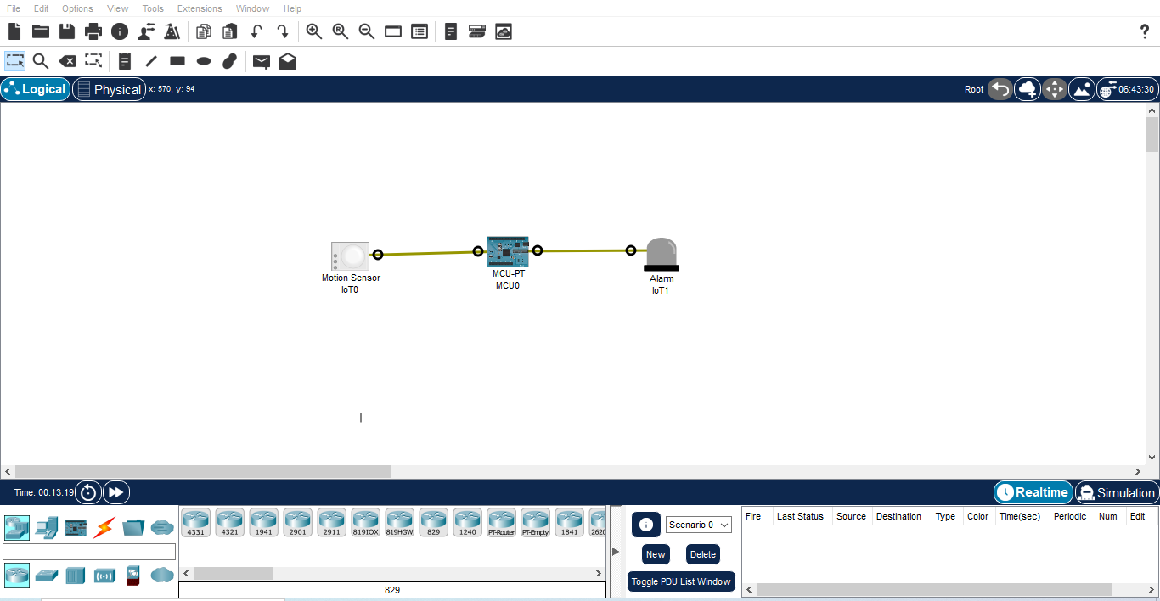

**Step 3 :** 1) Now click on MCU Board go to Programming then Select New, Select Template-

Empty-Python then click on Create

2) Click on main.py file then write code

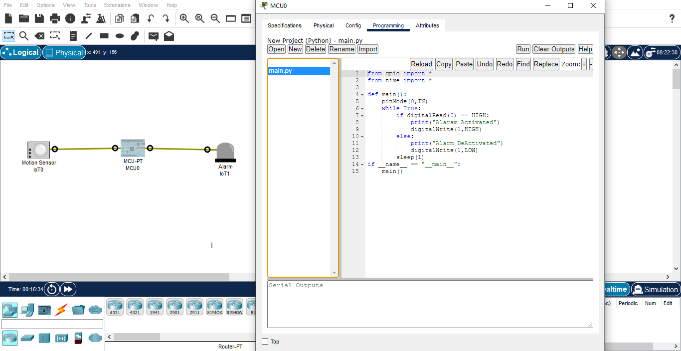

**Code :-**

from gpio import *

from time import *

def main():

pinMode(0,IN)

while True:

if digitalRead(0) == HIGH:

print("Alaram Activated")

digitalWrite(1,HIGH)

else:

print("Alarm DeActivated")

digitalWrite(1,LOW)

sleep(1)

if __name__ == "__main__":

main()

**Step 4 :** 1) Click on Run

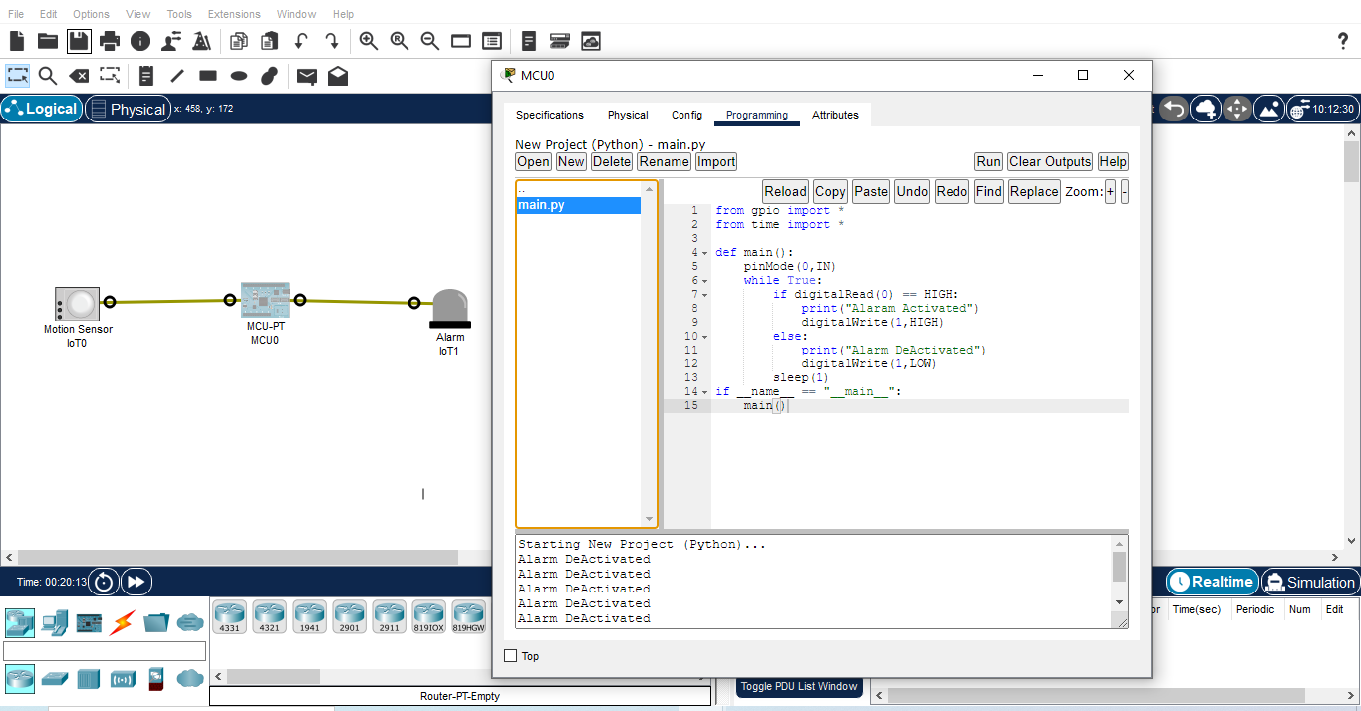

**1.(b) Timer based buzzer:**

**Steps to Perform:**

**Step 1:** 1) Take Component - MCU Board

2) Take Alarm

**Step 2:** 1) Now we will connect MCU board to Alarm with IoT custom cable connect MCU

Board (D0) to Alarm (D0)

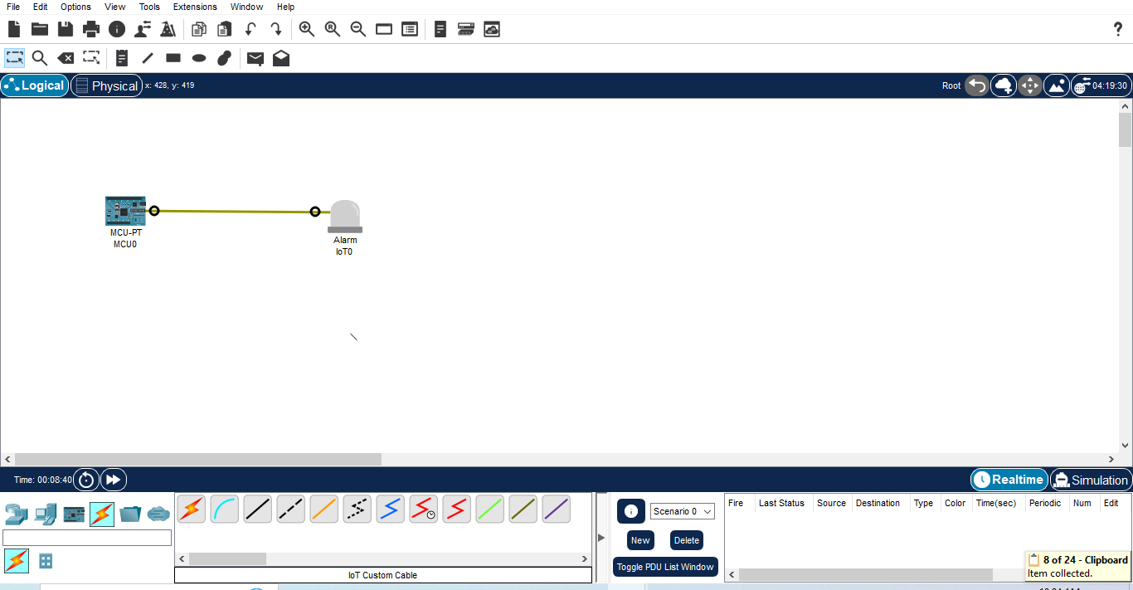

**Step 3:** 1) Now click on MCU Board go to Programming then Select New, Select Template-

Empty-Python then click on Create

2) Click on main.py file then write code

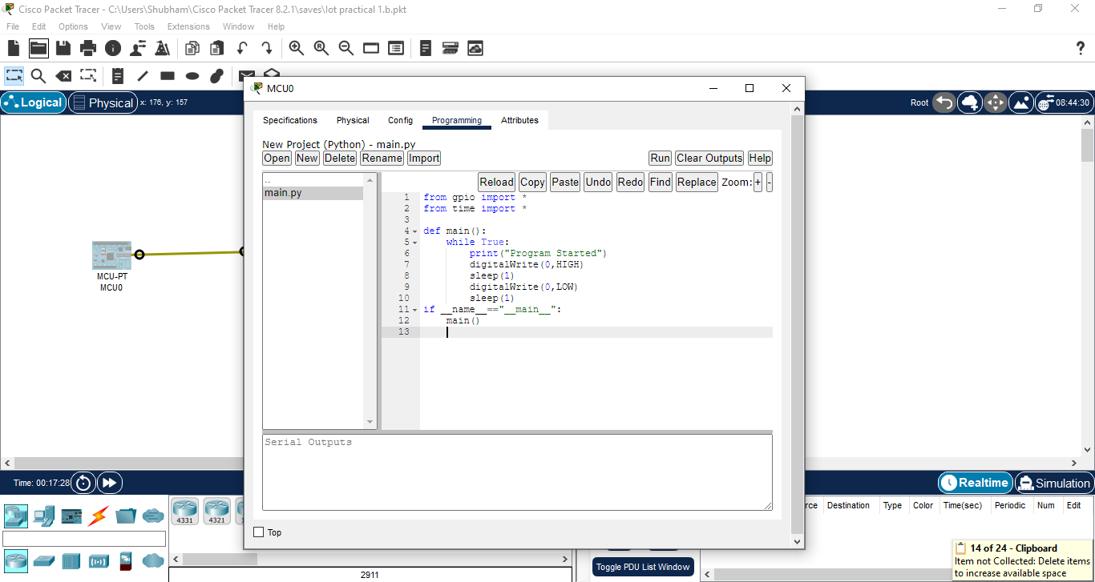

**Code:**

from gpio import *

from time import *

def main():

while True:

print("Program Started")

digitalWrite(0,HIGH)

sleep(1)

digitalWrite(0,LOW)

sleep(1)

if __name__=="__main__":

main()

**Step 4 :** 1) Click on Run

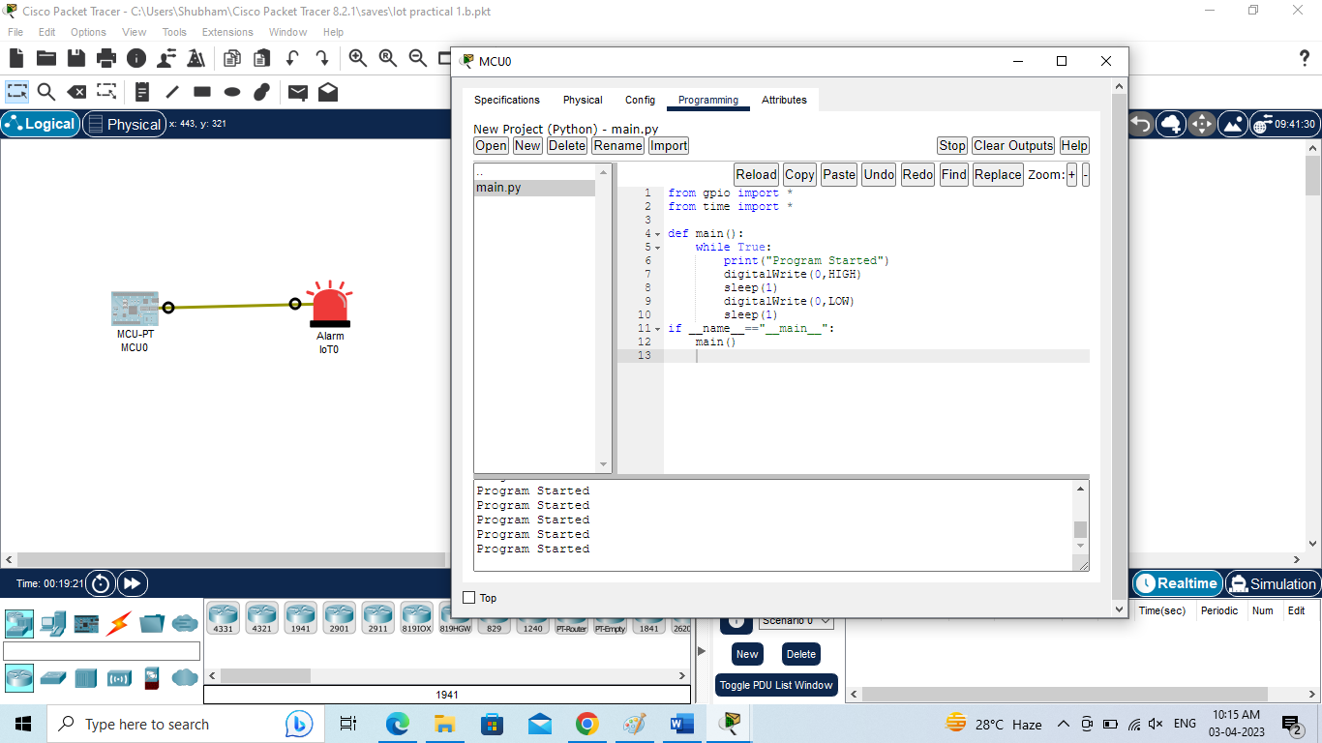

**1.(c) Sensor based Counting device:**

**Steps to Perform:**

**Step 1:** 1) Take Motion Sensor

2) Take Component - MCU Board

**Step 2:** 1) Now we will connect the Motion Sensor to MCU Board with

IoT custom cable connect Motion Sensor (D0) to connect with MCU Board (D0)

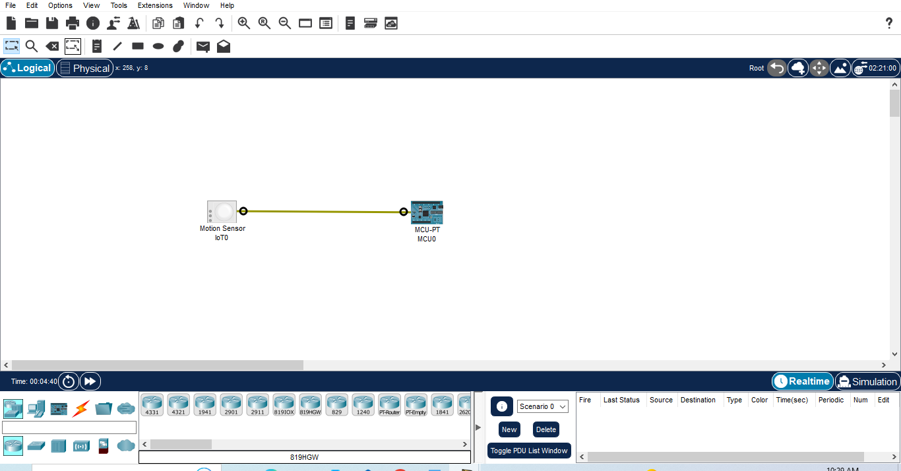

**Step 3 :** 1)Now click on MCU Board go to Programming then Select New , Select Template-

Empty-Python then click on Create

2) Click on main.py file then write code

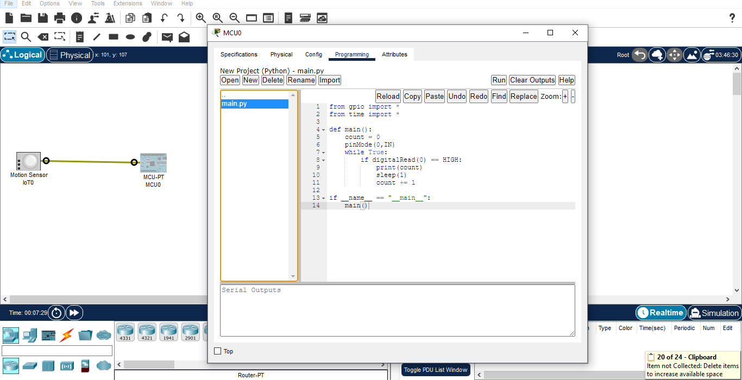**Code:**

from gpio import *

from time import *

def main():

count = 0

pinMode(0,IN)

while True:

if digitalRead(0) == HIGH:

print(count)

sleep(1)

count += 1

if __name__ == "__main__":

main()

**Step 4 :** 1) Click on Run

2) Press Alt button then Start Counting

